Training/workshop report
Two day training program was organized by National Center for Natural Resources, Pt. Ravishankar Shukla University Raipur for basics and instrumentation of Supercritical Fluid Extraction (SFE), dated November 03-04, 2022 at 11.00 am in Offline-mode. The program was inaugurated by Prof. M. K. Deb, Director of NCNR, Pt. Ravishankar Shukla University, Raipur. Doli Shrinivas from Hyderabad and Dr. Kurrey from School of Studies in Chemistry, Pt. Ravishankar Shukla University Raipur have given the lecture on his particular topics (basics and instrumentation of SFE) in this two day training program. In addition, in this program the numbers of research scholars from Pt. Ravishankar Shukla University Raipur have participate for the same. The program aimed to encourage the young Research Scholars and Students and gave the fundamental and basic knowledge on advanced and modern extraction technique like SFE to have handling and performed the experiments.
Some photograph during the session
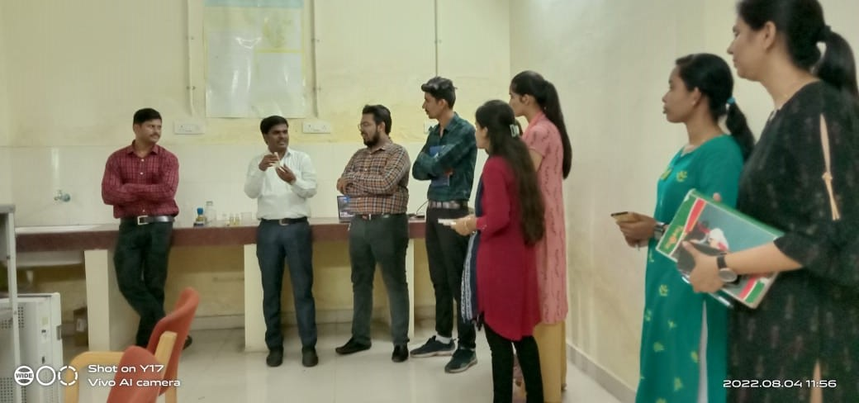
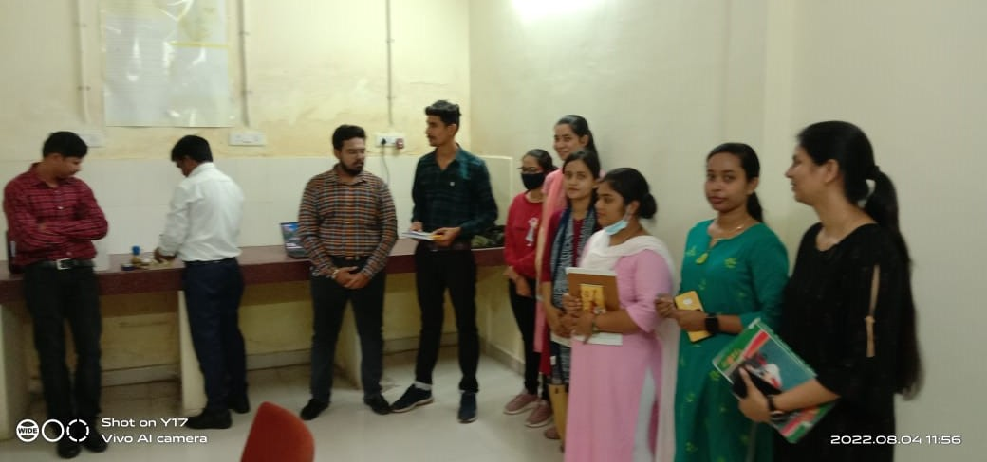
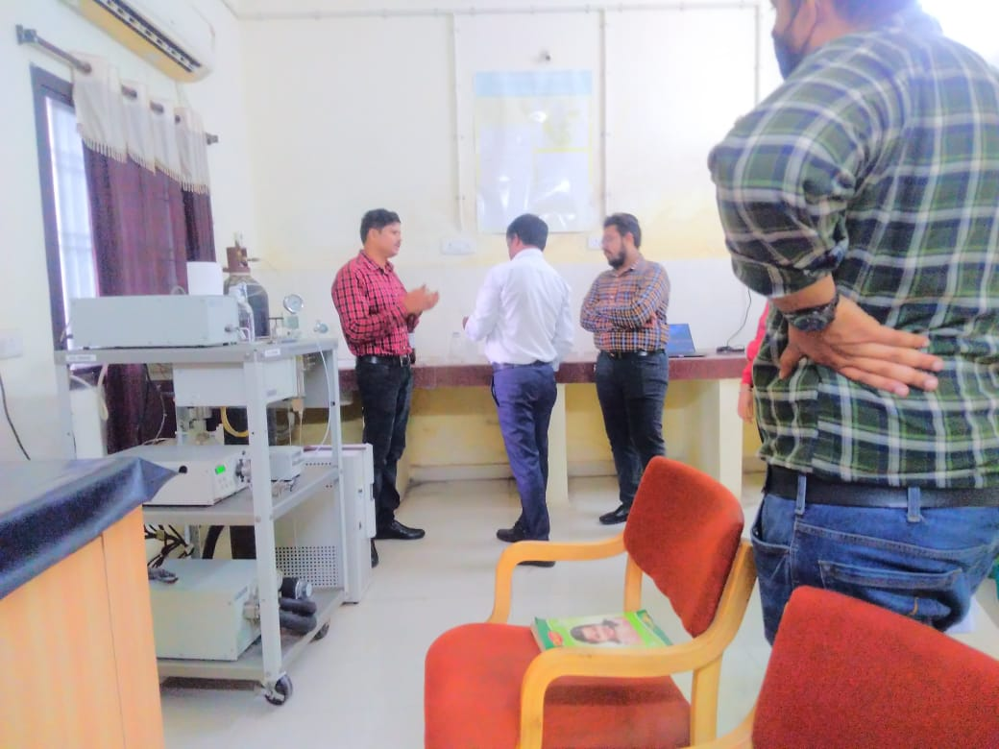
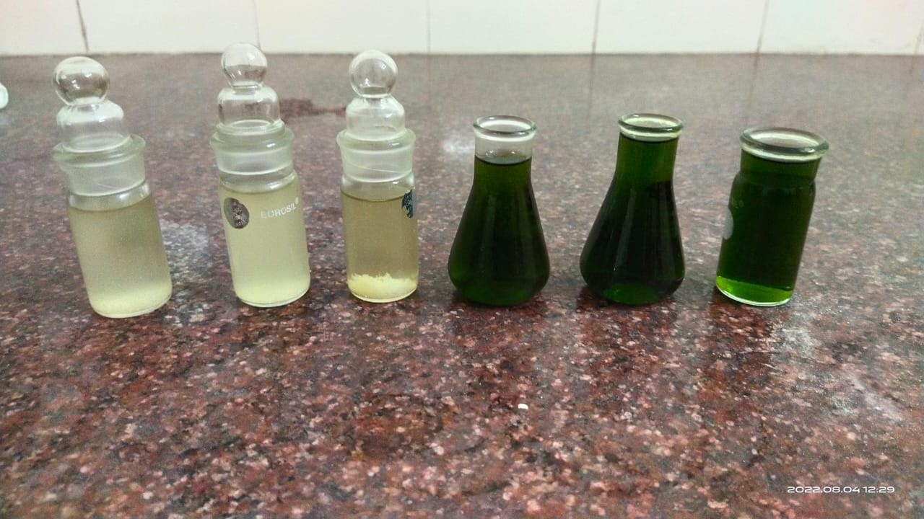
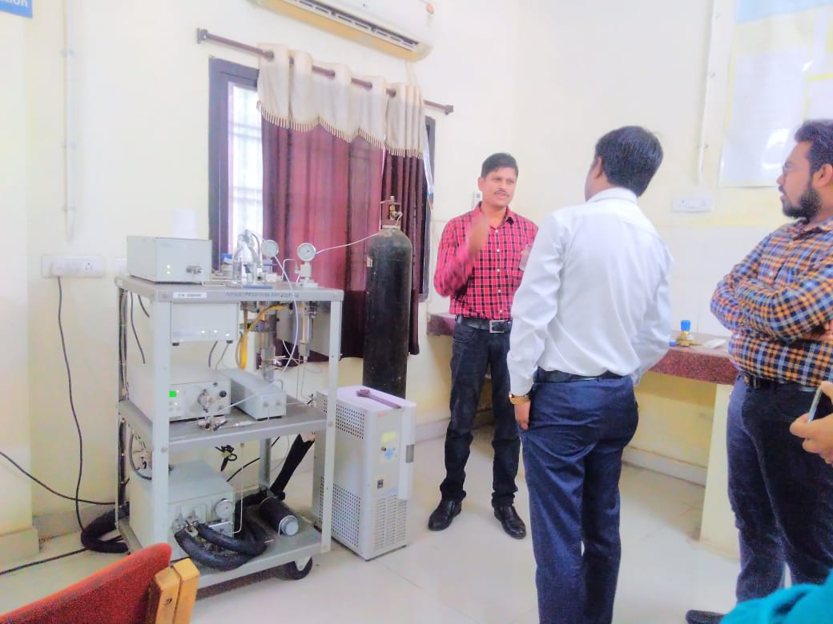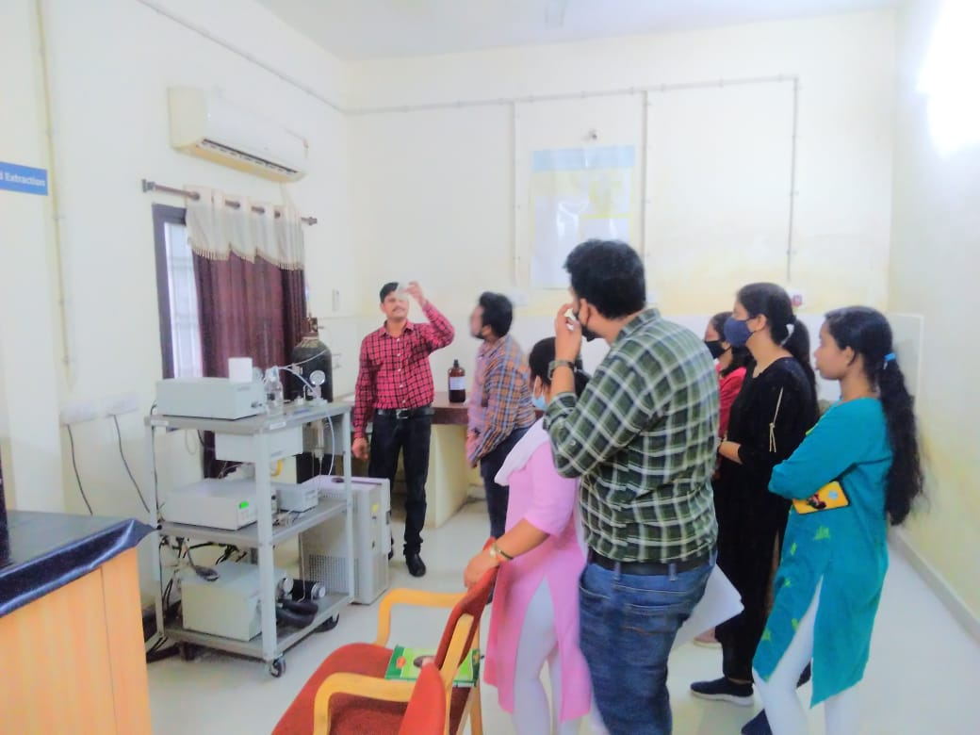

Dr. Ramsingh Kurrey  (Post-Doctoral Fellow) | Prof. Manas Kanti Deb  Director, NCNR

